Building and Editing Dashboards in Workday
Updated 1.7.2026 by Caroline Falkner

Definitions
Create a New Dashboard
Edit an Existing Dashboard
Configure Global Navigation
Adding a Workday-Delivered Worklet to Custom Dashboard
Creating and Managing Bulletin Worklets
Adding an Announcement to a Dashboard

Definitions

Dashboard
A Workday dashboard provides a consolidated view of key information and metrics, with quick links to relevant tasks, reports, and external resources to support day-to-day work. There are Workday delivered dashboards,Workday delivered dashboards can be customized, but are limited to one tab. If you need more flexibility, you can create a custom dashboard from scratch. (It is generally recommended to create custom dashboards so that you have more flexibility.)

Worklet
A worklet is a small, customizable widget or application that provides quick access to specific information or tasks. Worklets are typically displayed on a user’s Workday home page and allow users to interact with Workday data or functions in a simple, efficient manner without having to navigate through multiple menus. Workday uses the word “worklet” interchangeably and sometimes it has other names.

Create a New Dashboard
- If this is the first time you are attempting to create or edit a dashboard, ensure you have the appropriate security set-up.
  - Access to view/modify Set Up: Tenant Setup - Worklets
- Access the Create Custom Dashboard task. Input a name for your dashboard and click OK.
  - Note: You can change the title of the dashboard later, if needed.
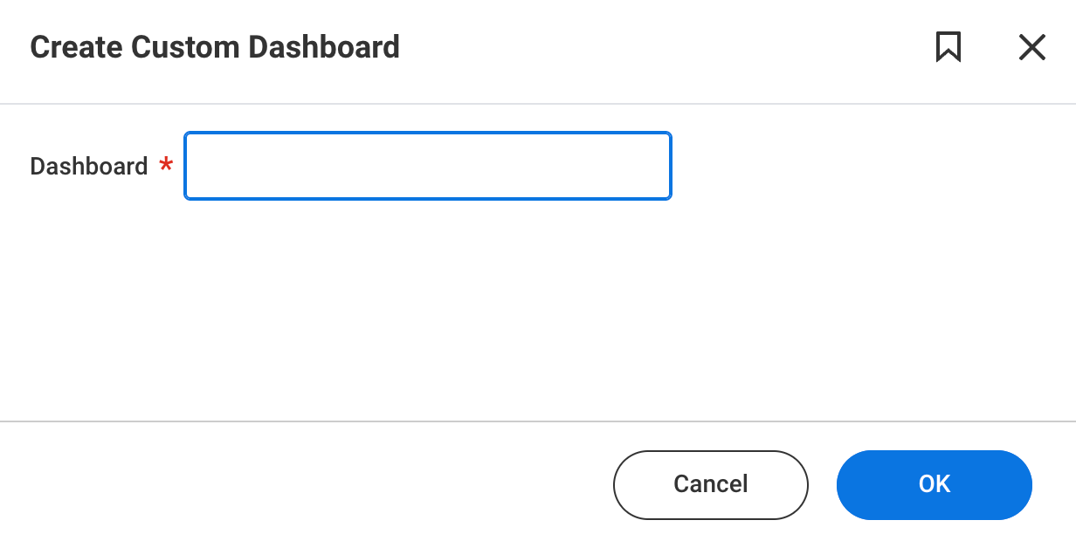
- On this page, complete the following:
  - Domains: Select ALL relevant domains.
    - Note: The selection of domains determines who has access to the dashboard. If an individual has access to any domain on the dashboard, they will be able to access the dashboard. However, security for each item within the dashboard is still respected.
  - Description: Include relevant information on who should be using the dashboard and for what purpose.
  - Dashboard Icon: Select an appropriate icon.
  - Max Worklets Allowed: 6. (This is the default.)
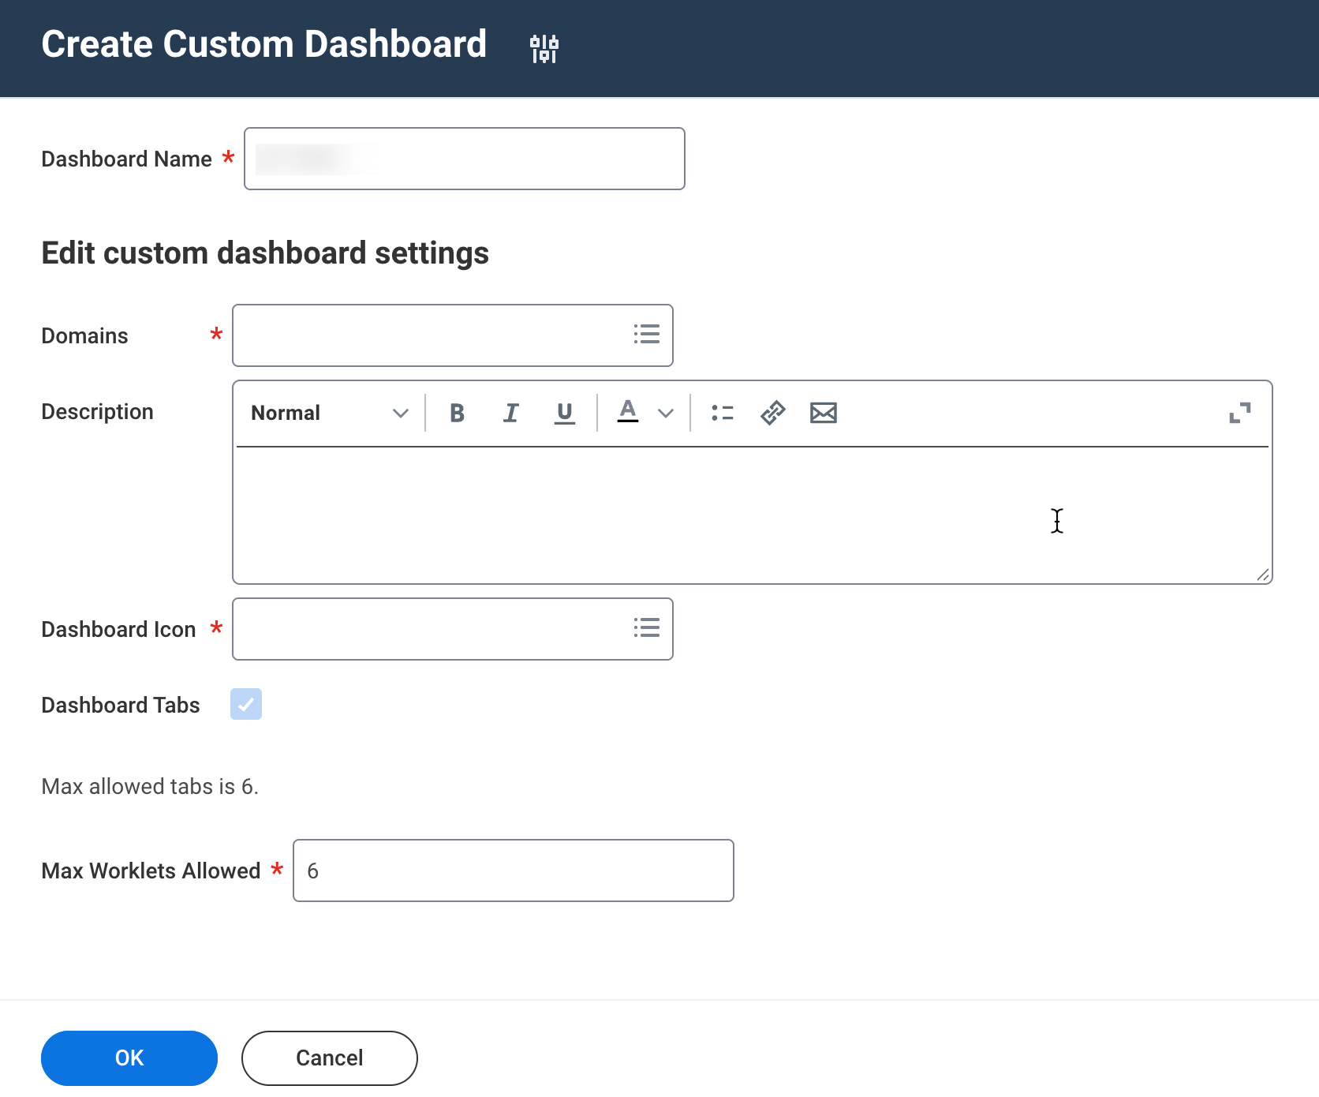
- Click OK.
- Next, navigate to the Maintain Dashboards report. Find the newly created dashboard and click the Edit button.
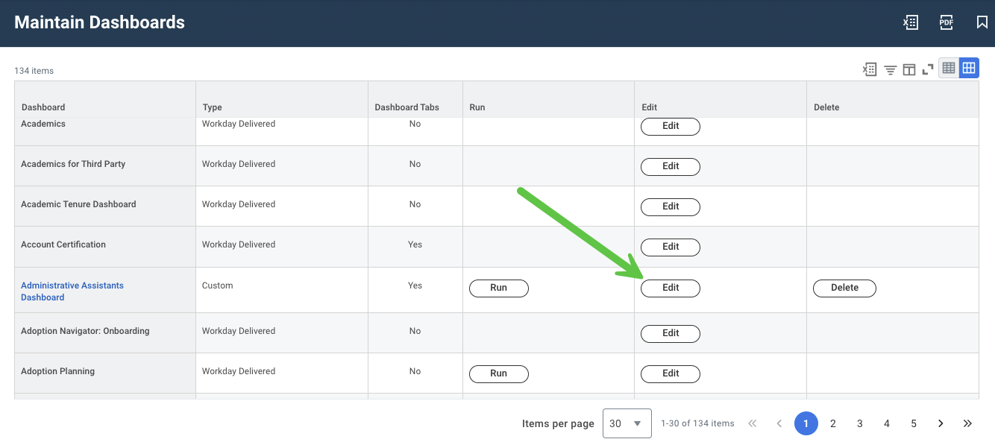
- On the Content tab, click Add.
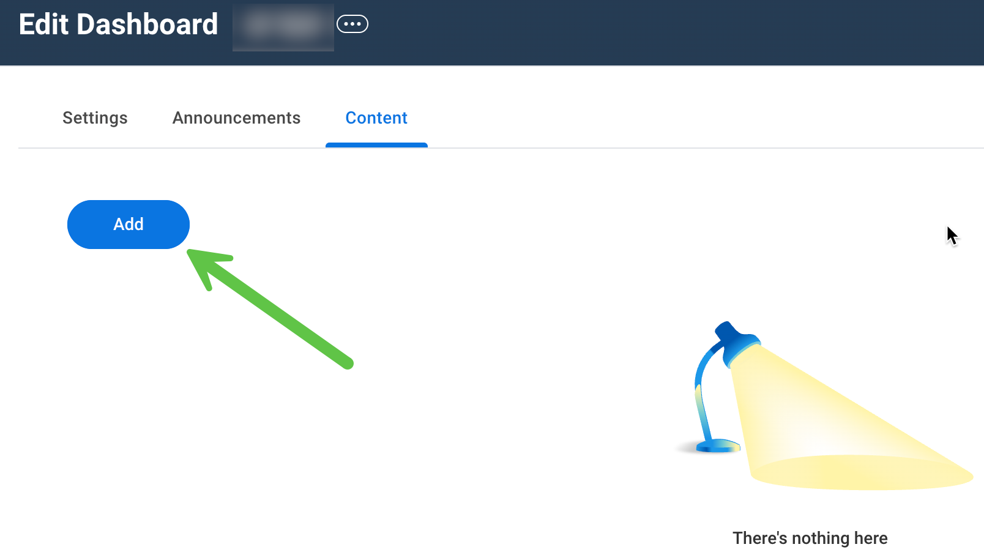
- Input a name for the tab (replacing the default name, e.g., Tab 083756).
  - Note: Tab names can be changed and updated as needed.
- Now you can start making choices regarding how the data and reports/tasks are displayed.
  - Bulletin Worklets (Use Worklets)
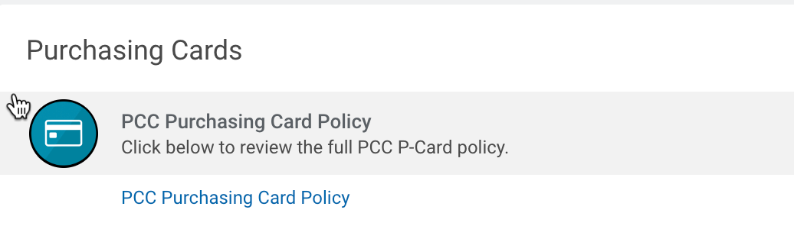
  - Imbedded reports (Use Worklets)
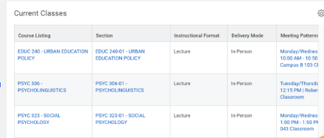
  - Direct links to tasks, reports, or external sites. (Use Menu)
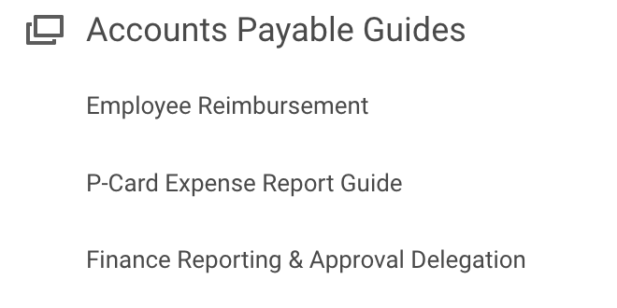
- For bulletin worklets or embedded reports, expand the Worklets section.
  - Click the “+” symbol. In the Menu Item dropdown, any reports that are enabled as worklets for this dashboard will display, along with any bulletin worklets that have been created for the dashboard.
    - If a report does not show in the dropdown, you’ll need to edit the report to enable it as a worklet and define the dashboard.
    - To create a bulletin worklet, select Create and select Create Bulletin Worklet.
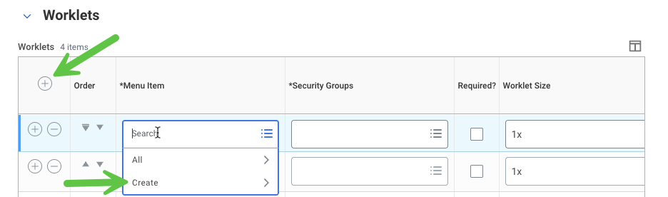
  - See Creating and Managing Bulletin Worklets for detailed information on creating a bulletin worklet.
- For Menu items, expand the Menu section. Click the “+” symbol. Input a label for the section.
  - Note: The location of the menu is not configurable, it always displays on the far right-hand side. You also cannot create multiple menus, all items in the menu section display in one long column.
  - The section label can be used to connect institutional language to Workday tasks. When a user can't remember the name of a task in Workday the section label can guide them to the task related to that topic.
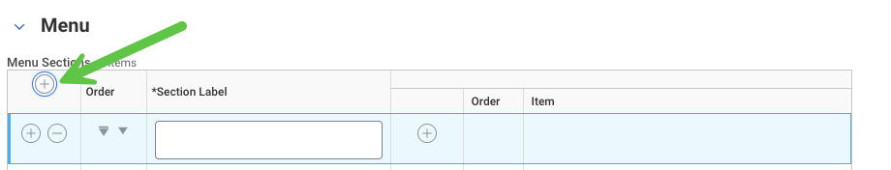
- To add items within that section, click the “+” sign.
  - Task: This references both Workday-delivered tasks and reports.
    - Depending on the domains that were added to the dashboard, you may be able to directly select the task from the dropdown. If it does not appear when you search, you need to select Create Custom Allowed Worklet Task.
    - Make sure to select the one associated with the right task for administrators and not one designated for students or instructors.
    - It’s typically NOT recommended to use the Add Custom Name option. While it can seem helpful, the sooner users familiarize themselves with the Workday terminology, the better they will be able to navigate.
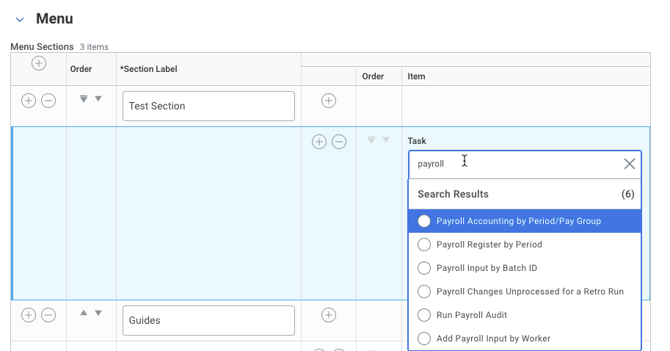
  - Custom Report: To add a custom report, search in this dropdown.
  - External Link: To add an external link, it must first be created as a QuickLink. It is recommended to search for a link first, before creating a new QuickLink. If a new QuickLink is needed, you can access the task directly from the dropdown.
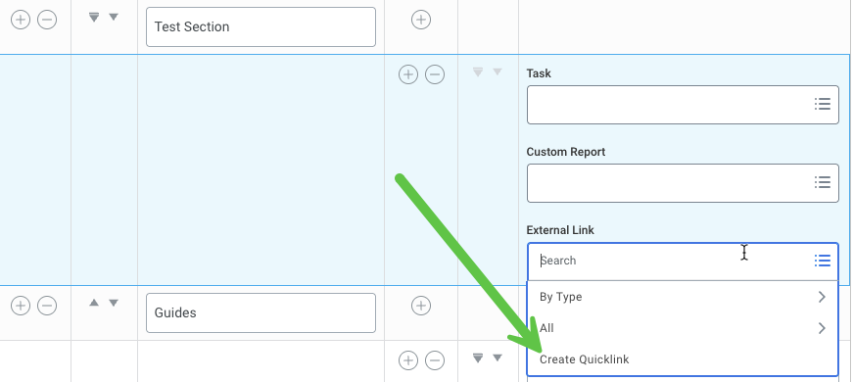

- Continue adding worklets and menu items on the tab. To create additional tabs, click the Add button on the Content page.
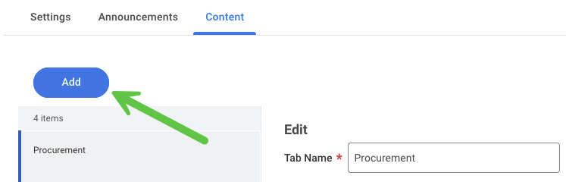
- (Optional) Ask a report writer to design a cool visual report that you can add in the worklet section.

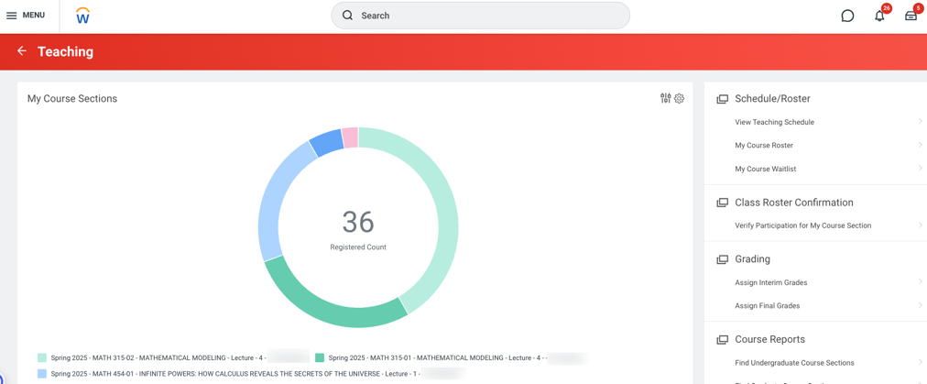
- Once the dashboard is created, it is available to users via the Search function. To add it to the global Menu navigation, additional steps are required (see Configure Global Navigation).

Edit an Existing Dashboard
- Access the Maintain Dashboards task. Find the dashboard you wish to update and click the Edit button.

- To make changes to the dashboard name, domains, or icon, click on Settings tab and select Edit button.
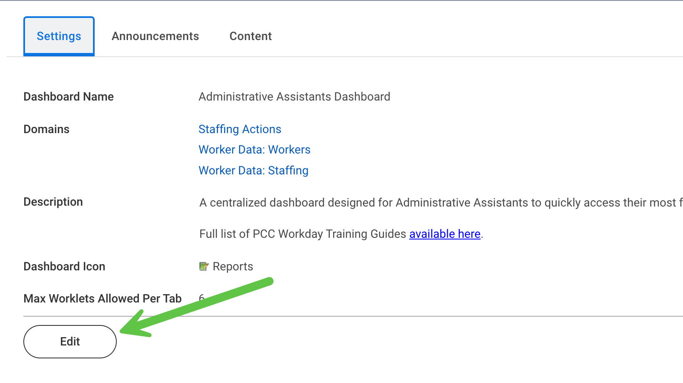
- To edit content on the dashboard itself, click on Content tab. You can then navigate between pages of the dashboard and add/remove content as needed.
- To update a link that is out of date, use the Maintain Quicklinks task. You can either edit the link of the existing quicklink or create a new quicklink. If creating a new link, you’ll need to update the item on the dashboard.
  - Note: Quicklinks can be used across Workday, so updating a quicklink will update it across the board, not just on the dashboard.
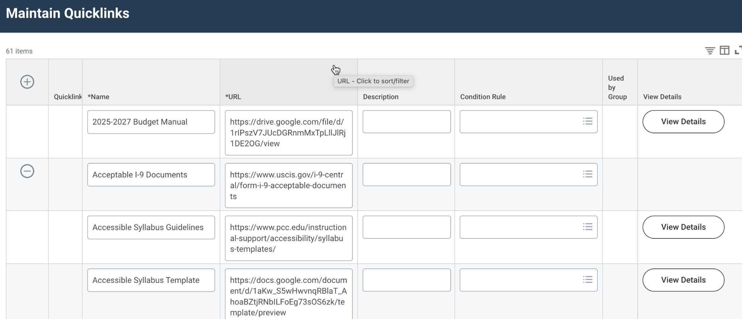

Configure Global Navigation
- Workday enables you to design the organization of menu items. To do so, access the Configure Global Navigation Menu task.
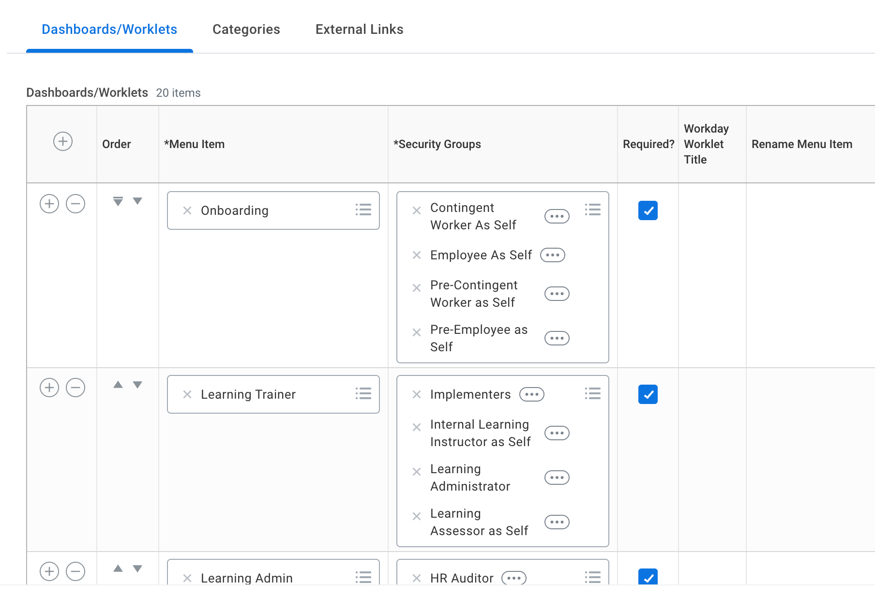
- Click on the Categories section. Set your category labels. This is what will display to users on the left hand navigation bar as a header with the dashboards/apps below it. Confirm across HCM/FIN/Student which categories each product area wants to use
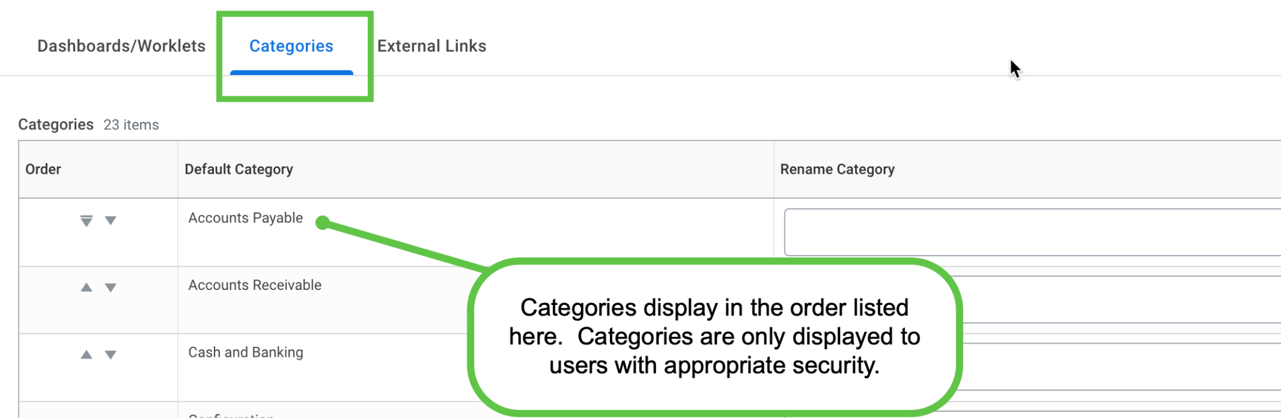
- Go to the Dashboards/Worklets tab. Customize which category the dashboard should go into. Even if you have used a label, the original category name will display here.
  - You can organize the Category Override. You can no longer set the order that the dashboards (apps) display. Dashboards only display in alphabetical order within the category.
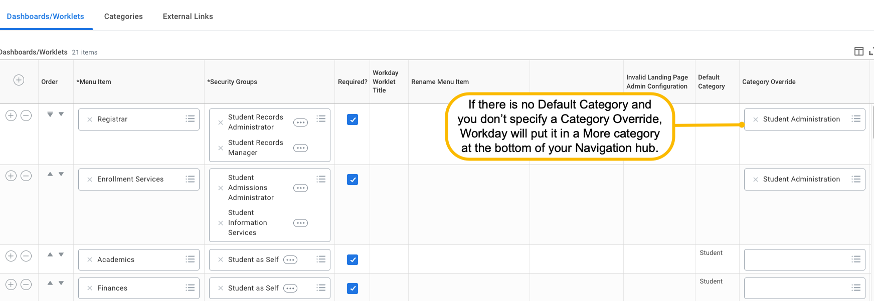

Adding a Workday-Delivered Worklet to Custom Dashboard
Workday creates delivered worklets. If you have a custom dashboard, you must enable a Workday-delivered worklet to appear.

- Access the Enable Worklet for Dashboards task.
- Select the worklet and select the dashboard you created.
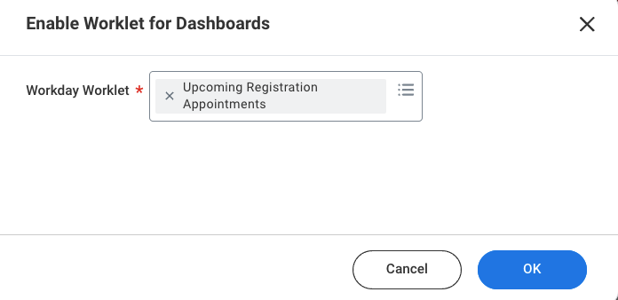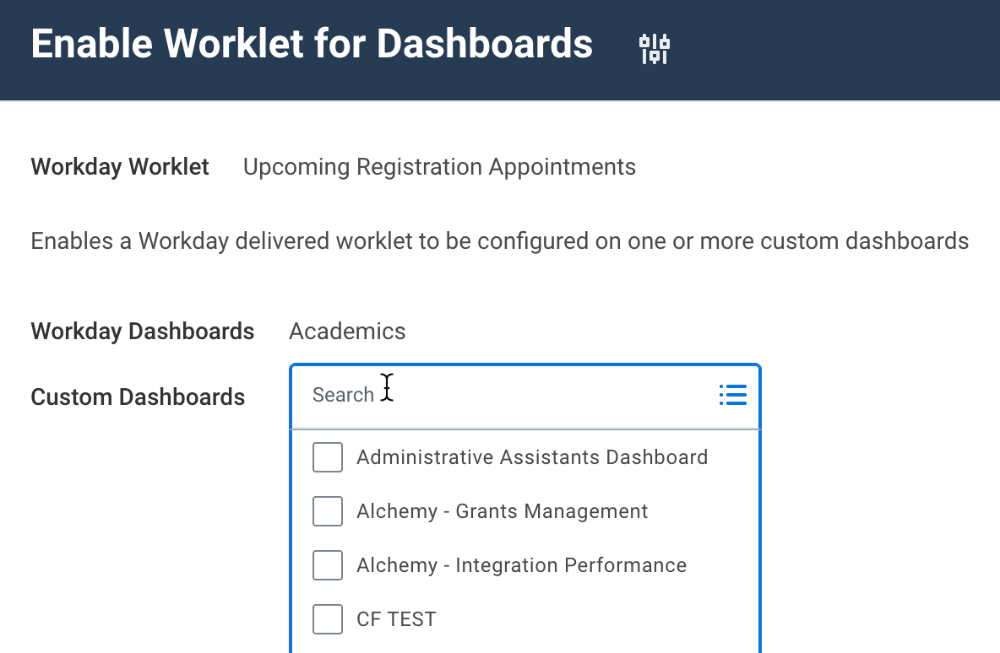

Creating and Managing Bulletin Worklets
A visually appealing way to display information to students is using the bulletin functionality. Bulletin worklets also allow use of condition rules so you can customize which users see the bulletin in their dashboard.

- Access the Create Bulletin Worklet task.
- Follow the below image to understand each aspect:
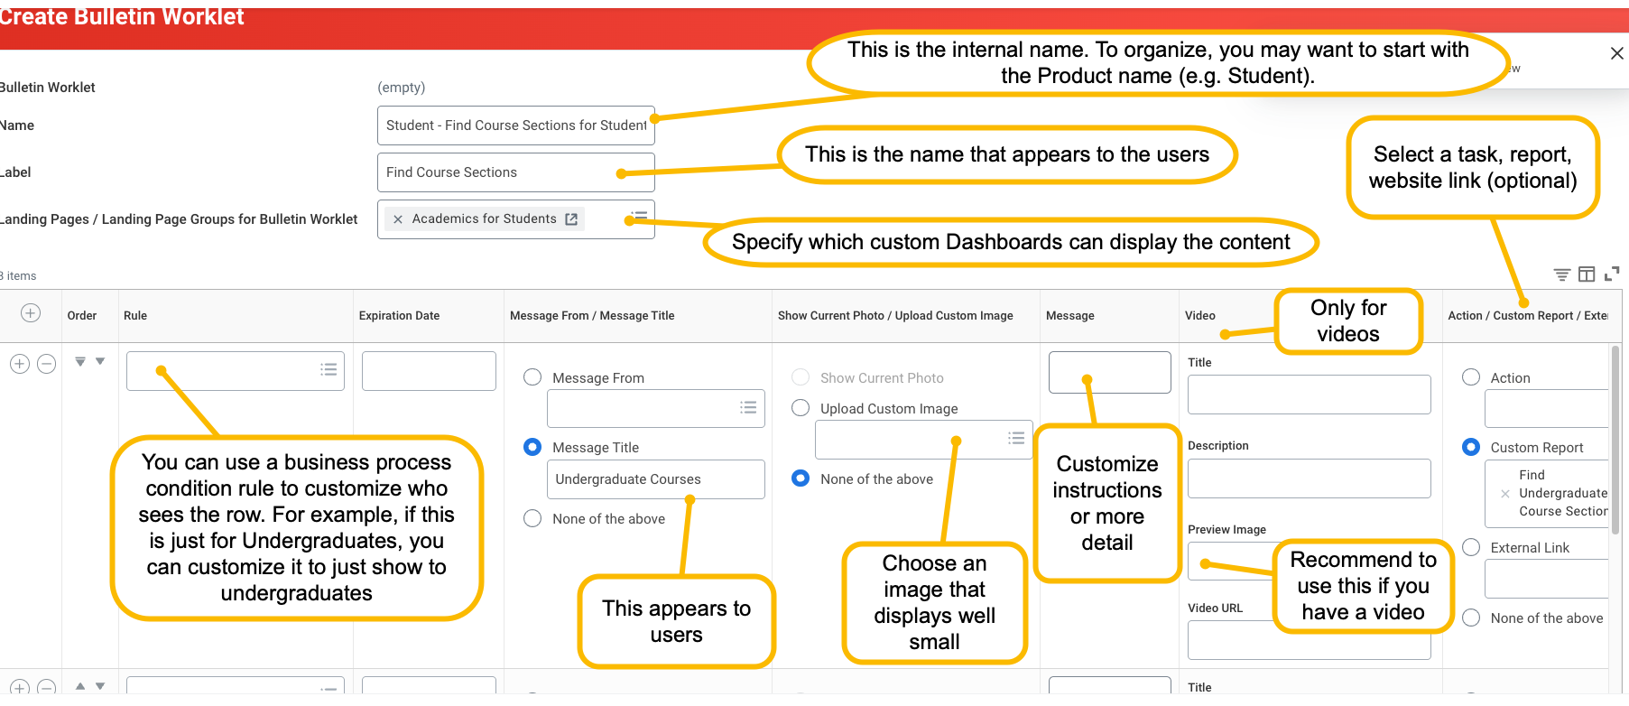
- Go to Maintain Dashboards and select the custom dashboard that you’re updating.
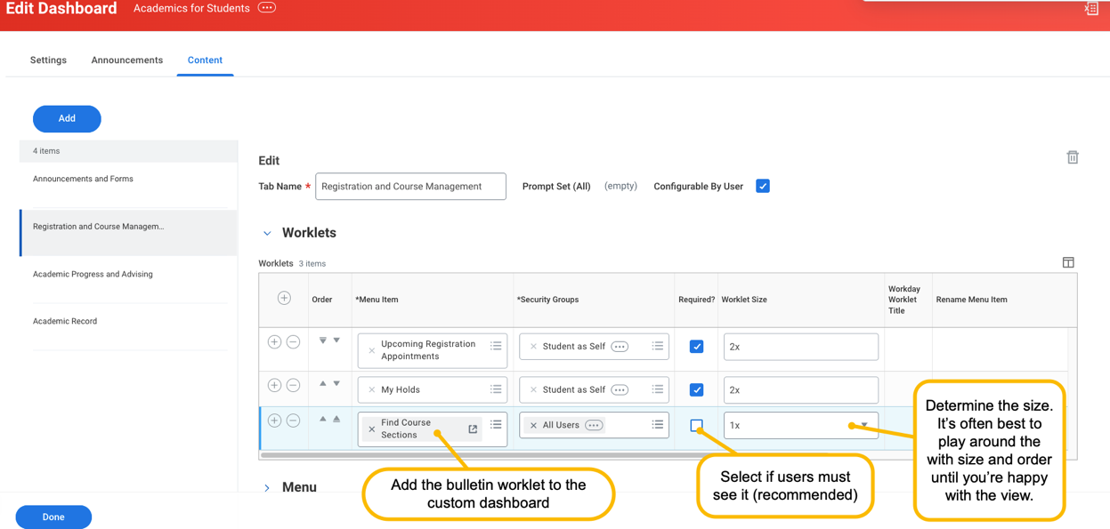
- Proxy as a user that meets the rules/security to confirm view. Adjust as needed.

Adding an Announcement to a Dashboard
- Access the Maintain Dashboards task.
- Find the dashboard and click Edit.
- Go to the Announcements tab and click the Edit button.
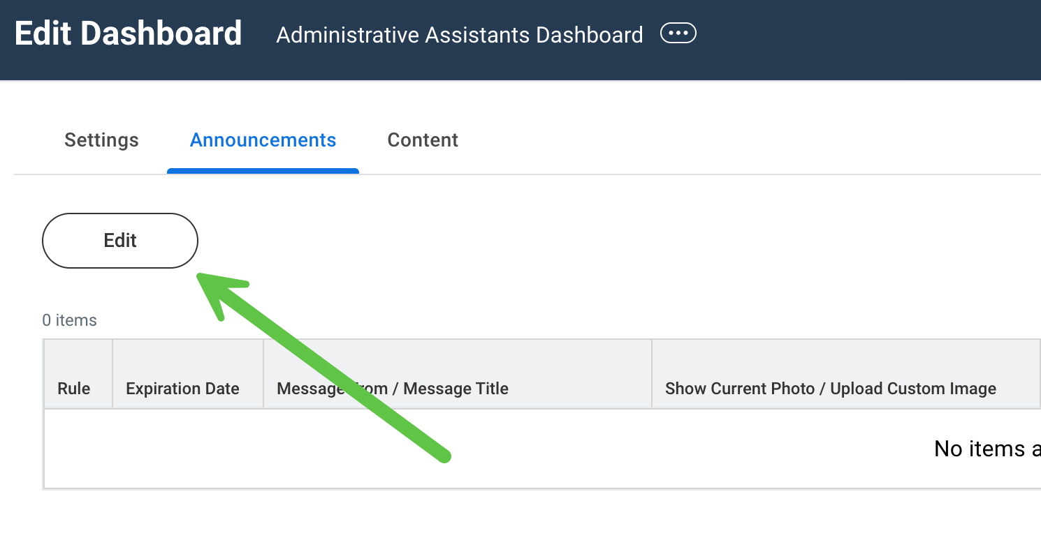
- Click the + sign.
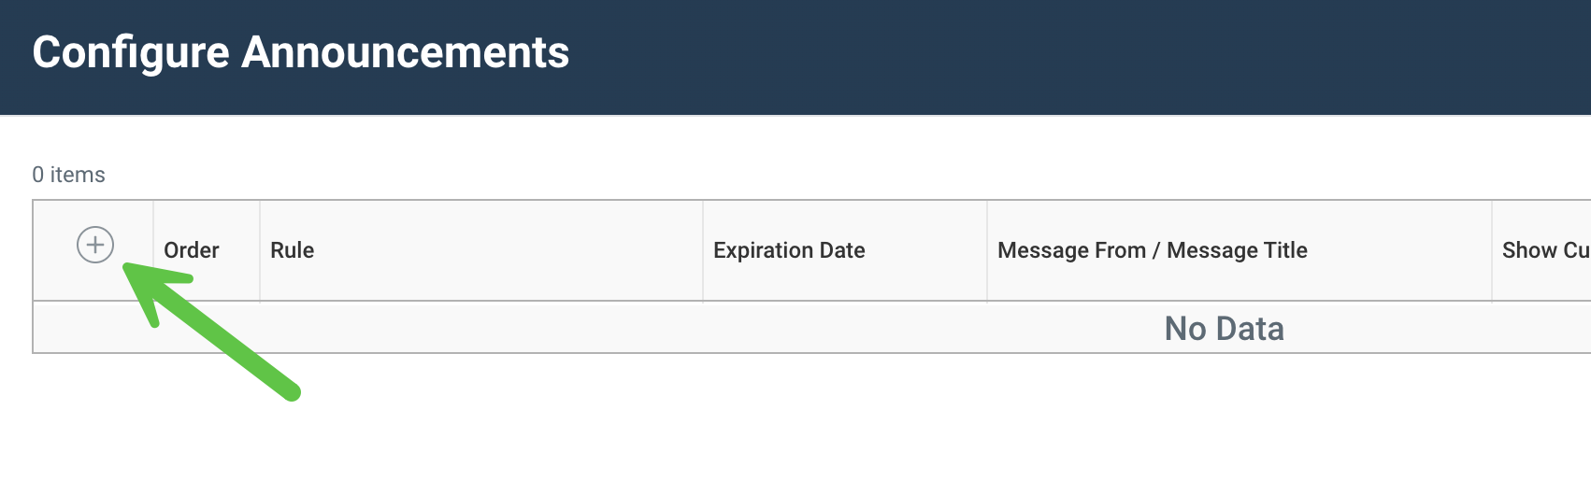
- If you want to use conditional logic to determine the audience who will see the announcement, add a rule.
- If you want an announcement to display only for a period of time, add an expiration date. If you want to just put a permanent message, leave blank.
- You have options for a message title, image, video, and direct link to task, report, external site. The content of the announcement is input in the Message section.
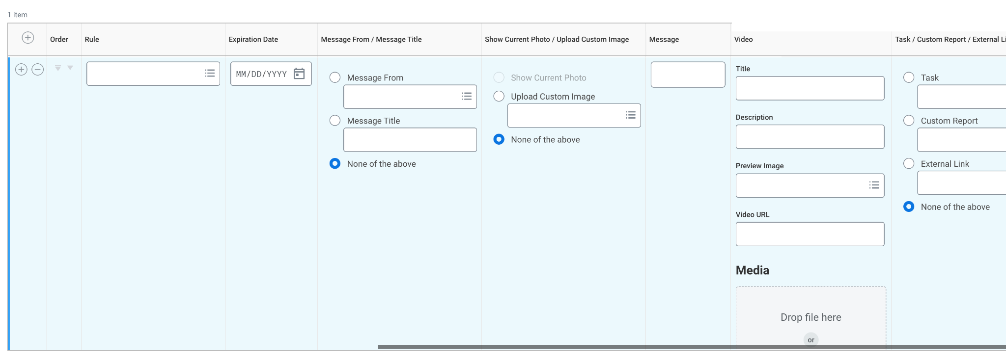
- Click OK to save.

